**MAKERERE UNIVERSITY**

**COLLEGE OF COMPUTING AND INFORMATION SCIENCES**

**SCHOOL OF COMPUTING AND INFORMATION SCIENCES**

**BACHELLOR OF INFORMATION SYSTEMS AND TECHNOLOGY**

**LECTURER’S NAME: MR GEORGE BITWIRE ALBERT.**

**COURSEUNIT NAME: WEB SYSTEMS 11.**

**Group 5**

|  |  |  |
| --- | --- | --- |
| **NAME** | **REG NO** | **STUDENT NO** |
| Napakol Joy Christine | 20/U/3429/PS | 2000703429 |
| Alukut Innocent | 20/U/22054/PS | 2000722054 |
| Mumbere Martin Mutooro | 20/U/1195 | 2000701195 |
| Nanyonga Angella | 20/U/3566/PS | 2000703566 |
| Namususwa Rachael JFK | 20/U/1198 | 2000701198 |
| Twebaze Evas | 20/U/22616 | 2000722616 |
| Nekesa Rodah | 20/U/3421/PS | 2000703421 |
| Angodo Francis | 20/U/22614 | 2000722614 |
| Nassaka Specioza | 20/U/3485/PS | 2000703485 |
| Sserugunda Daniel | 20/U/3581/PS | 2000703581 |

**A CASE STUDY OF NWSC BILL COMPOLAINT SYSTEM.**

The NWSC Bill complaint system is to solve the various complaints brought in by people concerning the different bills of water by the national water and sewerage cooperation.

The entities involved in the system include the following; staff, billing, branch, complaint form, client and administrator and these entities have various responsibilities on the system as explained below;

Meter reading, this is done by one or more than one of the staff members who move to various places to collect data related to the usage of water by the clients.

Handles complains, this is still done by one or more than one of the staff members who view client complaints and finds out all ways of responding to them, for example if there is a fault with the tap, the staff members work on how to fix the fault immediately so that client’s complaints are fixed.

Delivers available complaints; this is done by the system itself through receiving various complaints from clients who log onto the system 24/7, stores these complaints.

Receives complaints, the system receives complains after the complaint form has been submitted onto it, processes the form and then notifies each staff member about a client’s complain.

Specifies handled and unhandled issues this is done by the complaint form whereby clients fill the form and on it they are able to indicate which issues are already handled and those that are not handled so that they can be worked upon too.

Logs in, the administrator logs on to the system and by doing so, they are able to add clients onto the system and also make the necessary updates after which the system sends notifications back to the administrator about the changes made.

Makes payments, this is done by one or more than one client to the system immediately he or she registers with the system and a confirmation message of payment id delivered by the system to the client and still the client can use the system to check for his or her water bills. Staff members at the branch also manage the system which updates bills and delivers them to the people in need.

**Online water bills complaint system**

**How System works**



A – Meter reading

B – Delivers available complaints

C – Handles complaints

D – Receives complaints

E – Specifies handled and unhandled issues

F – Logs in

G – Add updates, clients

H – Sends notifications on status updates

I – Makes payments

J - Registers

K – Confirmation of payment

L – Checks for bills

M-Manages staff

N-Delivers bills

O-Update bills



**Assumptions**

* Assume one client views one Billing
* Assume one billing is viewed by one client
* Assume zero to many clients fill in a compliant form
* Assume zero to many compliant forms are filled in by a client
* Assume staff handles zero to many compliant forms
* Assume one compliant form is handled by one staff
* Assume one administrator monitors one staff
* Assume zero to two staff can be monitored by an administrator
* Assume one administrator is attached to one branch
* Assume one branched is attached to one administrator
* Assume one branch manages one staff
* Assume one staff is managed by one branch
* Assume one to many staff supervise a billing
* Assume one billing is supervised by one staff
* Assume one administrator adds one to many clients
* Assume one client is added by one administrator
* Assume one administrator updates one to many billings
* Assume one billing is updated by one administrator

THE DATABASE ADMINISTRATOR.

By using the MYSQL language, the database manager is able to create the dummy accounts for the clients at the back end. He or she first creates a database and it is given a name.

In the databases we create tables name in which these tables will be able to contain the necessary information needed after one is done filling in the form at the system created.

These involve various entities for example the name, email account and location of the clients, staff member involved, the meter box number of the client such that incase such information is filled by the client at the front end of the website, this information can be retained by the database administrator.

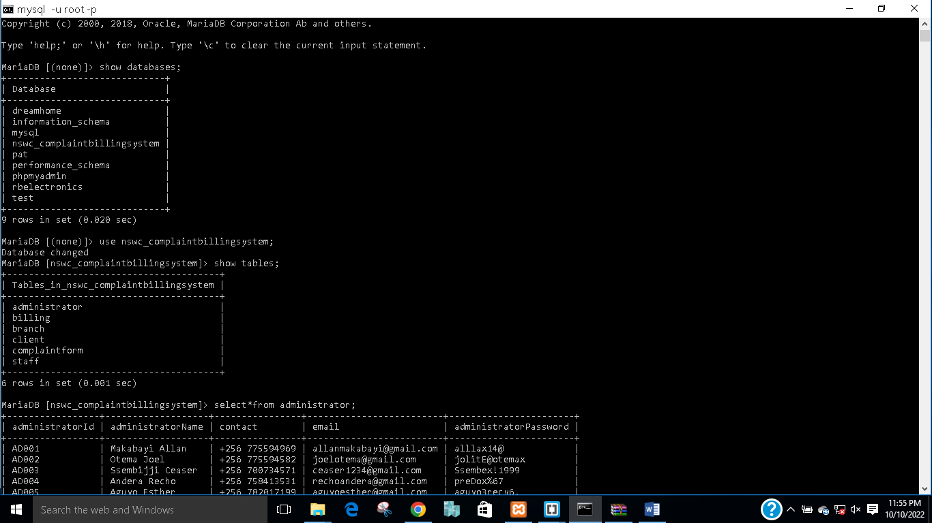

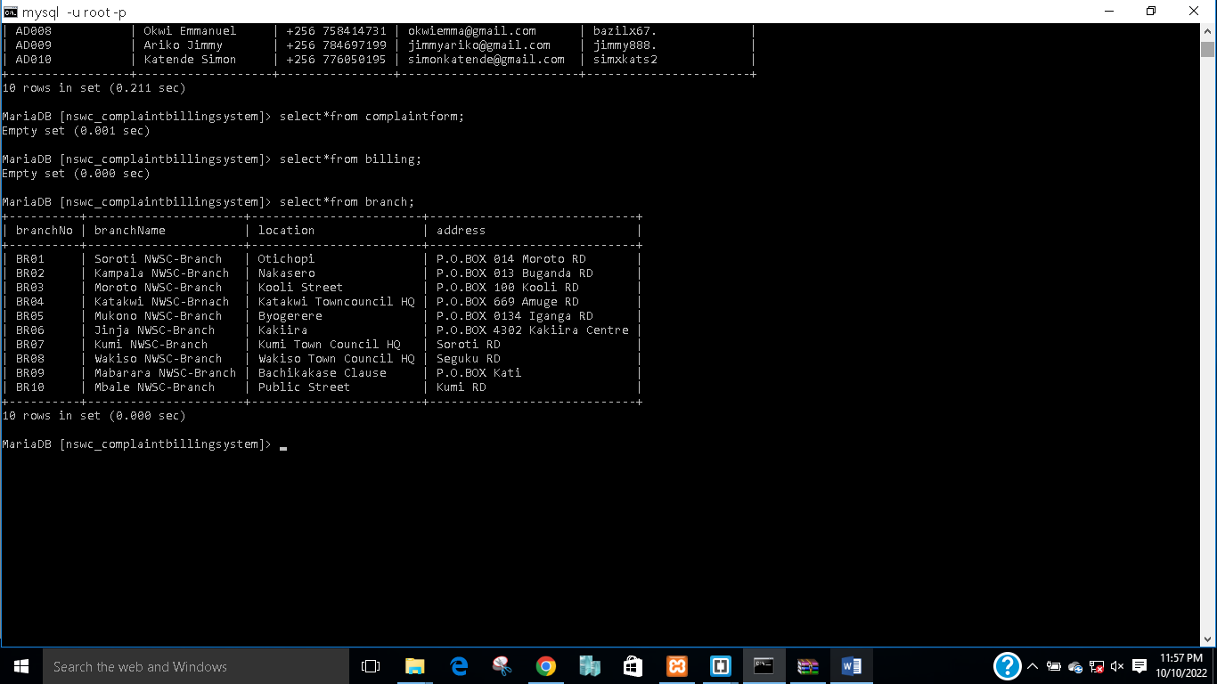

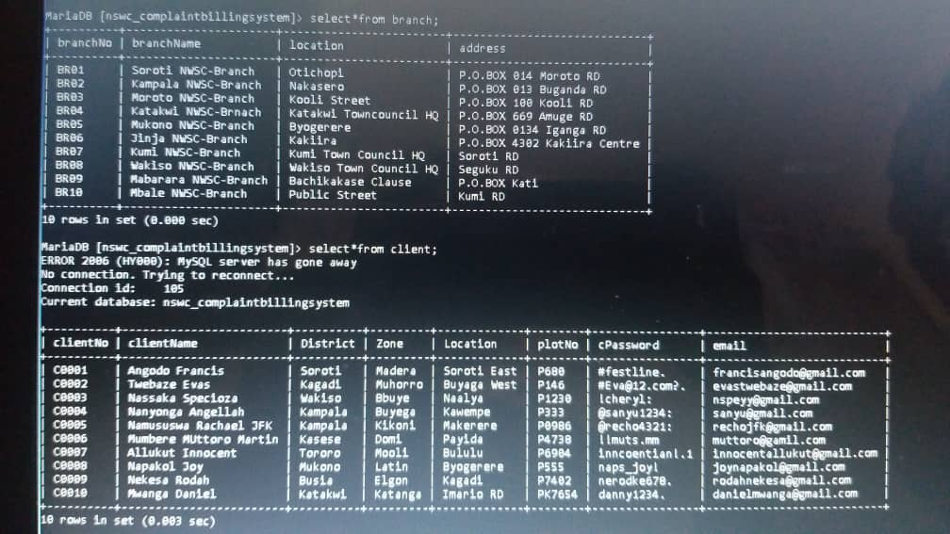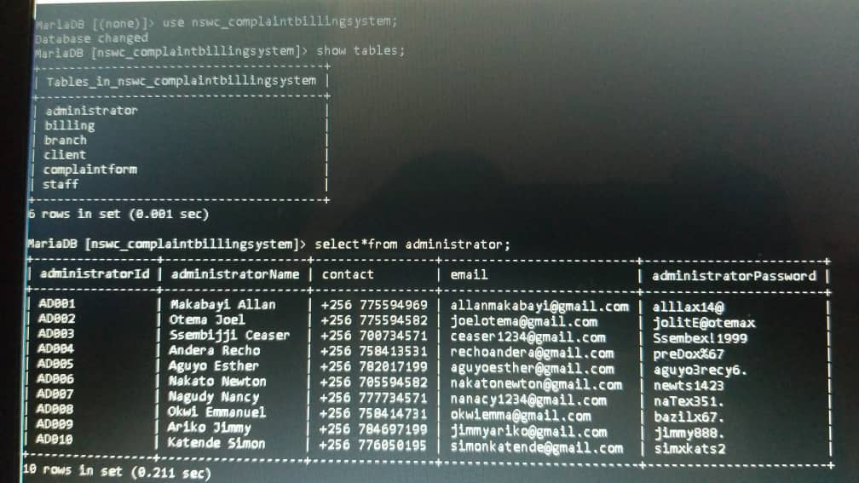

**THE NATIONAL WATER AND SEWERAGE CORPORATION BILLS COMPLAIN SYSTEM**

When a person uses the link for our system, they are taken to a page where they can either signup or login into their accounts. When one is signing up, there`s certain information got from them such as their names, NWSC account numbers, they are also required to create a password for their account and

also when one is logging in they are required to input their NWSC account numbers and the password they created when they were signing up.

**THE CLIENT’S DETAILS FORM.**

Here the client’s details are to be filled in by the client immediately he or she clicks on the button of logging in. All the details captured here are saved to the database created by the database administrator.

